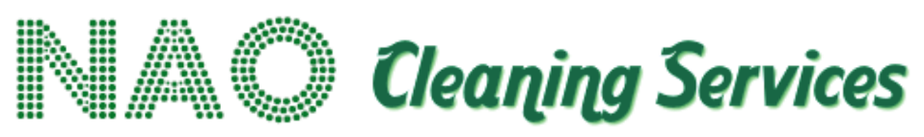

Anti-Bribery, Corruption & Fraud Policy

Policy Statement
NAO Services is committed to conducting business honestly, ethically and transparently.
We operate a zero-tolerance approach to bribery, corruption and fraud.

Bribery
Employees and representatives must not:
- Offer bribes.
- Accept bribes.
- Make improper payments.
- Request inappropriate financial or other advantages.
- Use gifts or hospitality to improperly influence decisions.
- Make improper payments through third parties.

Gifts and Hospitality
Reasonable and proportionate business hospitality may be acceptable where it has a legitimate business purpose.
Gifts or hospitality must never be used to influence:
- Tender decisions.
- Contract awards.
- Procurement decisions.
- Performance assessments.
- Commercial negotiations.

Procurement
Particular care will be taken during procurement and tendering activity.
Employees and representatives must not seek to improperly influence procurement officials, clients or evaluators.

Fraud
NAO Services will not tolerate:
- Falsification of records.
- False invoicing.
- Expense fraud.
- Theft.
- Deliberate misrepresentation.
- Financial manipulation.
- Collusion.

Reporting
Suspected bribery, corruption or fraud must be reported to senior management.
Concerns will be investigated appropriately and confidentially.

