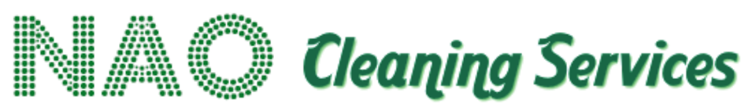

Health & Safety Policy

Policy Statement
NAO Services is committed to ensuring, so far as is reasonably practicable, the health, safety and welfare of all employees and to protecting clients, service users, visitors, contractors and members of the public who may be affected by our cleaning activities.
We recognise that effective health and safety management is fundamental to delivering safe, reliable and professional cleaning services.
NAO Services will comply with applicable health and safety legislation and continually seek to improve its health and safety performance.

Our Commitments
NAO Services will:
- Provide and maintain safe systems of work.
- Identify workplace hazards and undertake suitable and sufficient risk assessments.
- Develop site-specific Risk Assessments and Method Statements (RAMS) where required.
- Assess and control exposure to hazardous substances in accordance with COSHH requirements.
- Provide suitable PPE and ensure employees understand when and how it must be used.
- Provide appropriate information, instruction, training and supervision.
- Ensure cleaning machinery and equipment is suitable, maintained and used by competent personnel.
- Manage risks associated with slips and trips, manual handling, lone working, working at height, electrical equipment and cleaning chemicals.
- Maintain appropriate accident, incident and near-miss reporting arrangements.
- Investigate incidents and implement corrective actions.
- Consult employees on matters affecting their health and safety.
- Cooperate with clients and other contractors regarding site-specific safety arrangements.
- Maintain appropriate emergency procedures.
- Review health and safety performance regularly.

Risk Assessment
Risk assessments will be undertaken for relevant activities and reviewed when:
- Working practices change.
- New equipment or chemicals are introduced.
- A significant incident occurs.
- A new site is mobilised.
- Client requirements change.
- Existing controls are considered insufficient.
Employees will be informed of relevant control measures before undertaking work.

COSHH
Cleaning chemicals and other hazardous substances will be assessed before use.
NAO Services will seek to minimise unnecessary chemical exposure and ensure appropriate arrangements are in place for:
- Storage.
- Handling.
- Dilution and dosing.
- PPE.
- Spill response.
- Disposal.
- Access to relevant safety information.
Employees must not introduce unauthorised chemicals onto client sites.

Equipment
Cleaning equipment will be appropriately selected for the task, maintained and inspected as required.
Employees must report damaged or defective equipment promptly and must not continue using equipment they believe to be unsafe.

Training
Employees will receive appropriate induction and role-specific health and safety training.
Training requirements may include COSHH, manual handling, PPE, machinery, slips and trips, lone working, working at height and site-specific safety arrangements.
Training records will be maintained.

Accident and Incident Management
All accidents, incidents, near misses and dangerous occurrences must be reported promptly.
Significant incidents will be investigated to establish root causes and identify preventative actions.
Where applicable, incidents will be reported in accordance with RIDDOR requirements.

Responsibilities
Senior management has overall responsibility for health and safety.
Managers and supervisors are responsible for implementing safe working arrangements and monitoring compliance.
Every employee has a responsibility to:
- Follow training and safe systems of work.
- Use PPE appropriately.
- Report hazards.
- Report accidents and near misses.
- Use equipment correctly.
- Take reasonable care of themselves and others.

Monitoring and Review
Health and safety performance will be monitored through inspections, audits, incident analysis, employee feedback and management review.
This policy will be formally reviewed at least annually.

