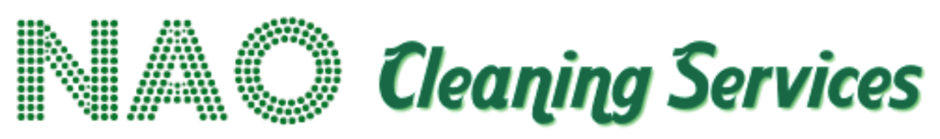

Safeguarding Policy

Policy Statement
NAO Services recognises that employees may provide cleaning services in environments used by children, young people and adults who may be at risk.
We are committed to promoting their safety and ensuring employees understand how to recognise and report safeguarding concerns.

Principles
NAO Services will:
- Maintain appropriate professional boundaries.
- Undertake employment checks proportionate to the role.
- Undertake DBS checks where required by the contract or nature of the role.
- Provide safeguarding awareness where appropriate.
- Require employees to comply with client safeguarding arrangements.
- Treat safeguarding concerns seriously.
- Escalate concerns promptly.
- Maintain appropriate confidentiality.
- Cooperate with clients and statutory authorities where required.

Reporting Concerns
Employees who witness or become aware of something that causes a safeguarding concern must report it promptly to their manager and/or the designated safeguarding contact specified for the site.
Employees should record factual information and should not attempt to investigate an allegation themselves.
Where there is an immediate risk of harm, appropriate emergency or safeguarding procedures must be followed.

Professional Conduct
Employees must behave professionally while working on client premises and must not:
- Develop inappropriate relationships with vulnerable service users.
- Exchange inappropriate personal contact information.
- Photograph individuals without authorisation.
- Share confidential information.
- Use inappropriate language or behaviour.

Training
Safeguarding training will be provided where proportionate to employees' roles and the environments in which they work.

