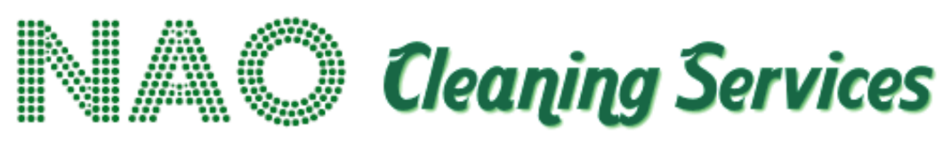

Quality Management Policy

Policy Statement
NAO Services is committed to delivering consistent, reliable and high-quality cleaning services that meet contractual specifications, client expectations and applicable standards.
Our approach is based upon:
Plan → Deliver → Inspect → Correct → Improve

Service Planning
Each contract will be planned according to its requirements and may include:
- Cleaning specifications.
- Task schedules.
- Cleaning frequencies.
- Staffing arrangements.
- Equipment requirements.
- Site-specific instructions.
- Quality standards.
- KPIs.
- Reporting requirements.

Service Delivery
Employees will receive appropriate instructions and training to enable them to deliver services consistently.
Supervisors and managers will provide appropriate oversight.

Inspection and Audit
Quality will be monitored through measures such as:
- Supervisor inspections.
- Cleaning audits.
- Site visits.
- Client feedback.
- KPI monitoring.
- Complaints analysis.
- Corrective action tracking.

Non-Conformance
Where standards are not achieved, NAO Services will:
- Record the issue.
- Assess its severity.
- Take immediate corrective action where appropriate.
- Identify the underlying cause where necessary.
- Implement preventative action.
- Verify that the issue has been resolved.

Continuous Improvement
Performance information will be used to identify opportunities for improvement.
Employees will be encouraged to suggest improvements to working methods, quality, safety, sustainability and customer experience.

Client Reporting
Where required contractually, NAO Services will provide performance information in an agreed format and participate constructively in contract review meetings.

